# Ryan Timbrook

## IST 659 Data Admin Concepts &Db Mgmt

## Date: 7/15/2018

## Lab Assignment: Week 1, The Relational Data Model

## Description / Learning Objective

* Demonstrate understanding of the relational database model
* Identify ways the relational database model improves upon file-based data storage systems
* Demonstrate basic model creation using diagramming tools

## Tasks:

* Identify problem spots and recommend improvements that the relational data model can afford
* Use an online software tool to create a basic diagram

## To-do:

* **Review the VidCast Datasheet and find ways to improve it.**
* **Identify at least 4 challenges to fitting this data into the relational data model.**
  + **Example: “Not every row in the sheet has a user name”**

## Responses:

### Question 1, Part 1 – Identify at least 4 challenges

#### Challenges:

1. **Not every row in the sheet has User Tags**
2. **Not every row in the sheet has Followers and some of the rows values are numeric counts of the number of followers they have rather than the required names of the users that are following them.**
3. **Not every row in the sheet has a Stream Date and the field values in these rows are varchar’s that will need to be cleaned and translated into proper datetime formatted values**
4. **Not every row in the sheet has a Video Duration and the field values in these rows are varchar’s that will need to be cleaned and translated into a duration data type like numeric and specified as milliseconds**
5. **Not every row in the sheet has a File Location specified**

### Question 1, Part 2 – Creating a basic ERD using draw.io

#### Lab 01 – Basic ERD

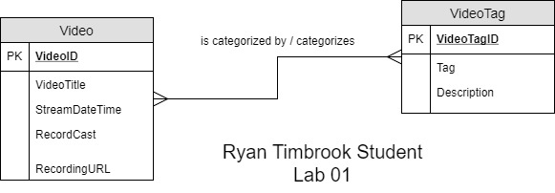

## Appendix – Tables and Diagrams used in this lab

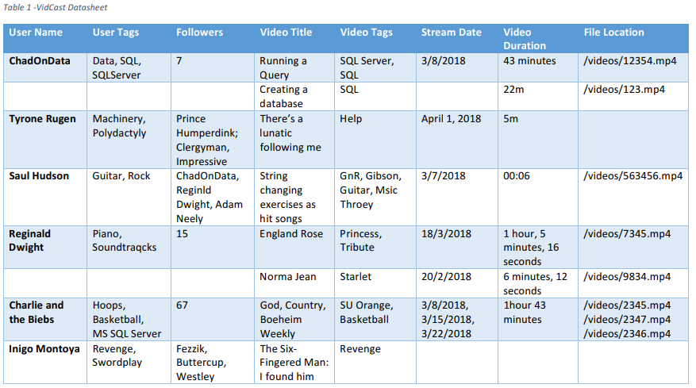

## Extract from Lab

